The Winning Factors to the English Premier League (EPL):
Leveraging Clustering Methods to Enhance Predictive Accuracy and Strategic Decisions

Group Members
CHENG Chun Ho (1155242350) | FONG Ka Po (1155249871)
CHOI Tsz Ki (1155094639) | LAM Yee Wing (1155250008)
TSOI Chung Him (1155242356) | TOH, Jing Jie (1155244156)

Background and Objectives 3
Dataset and Data cleaning 3
Data analysis and modelling result 4
Defining the optimal number of clusters 4
The Elbow curve 4
K-means Clustering and Silhouette Analysis 4
Hierarchical Clustering 5
DBSCAN 6
Diving into The Five Football Archetypes 7
Relating Clusters to Match Outcomes 9
Applying Random Forest Regression to predict match goals 10
Key Insights with Impact 11
Broadcasting Strategy 11
Betting Market Intelligence 12
Team Analytics Enhancement 13
Model Limitations 14
Recommendations, Next Steps, and Conclusion 15
Recommendations 15
Next Steps 16
Conclusion 17

Background and Objectives
The English Premier League (EPL) is one of the world’s leading international football leagues, offering a highly competitive platform for professional players to perform and for global audiences to engage through viewing and betting. With such large demand and scale, the EPL also indirectly generates comprehensive datasets in football, enabling in-depth statistical analysis and the development of predictive models that reflect real-world dynamics.
Football matches end in one of three outcomes: win, loss, or draw. Traditionally, each match is evaluated using a limited set of indicators—such as number of shots, yellow cards, red cards, and corners while most of the existing algorithms often rely on these isolated metrics to predict outcomes, typically focusing on data from one side only.

This report aims to uncover hidden patterns of EPL matches through unsupervised machine learning techniques, specifically clustering methods. Building on the findings, this report attempts to include cluster archetypes as an additional feature in traditional supervised model in forecasting winning teams by goal differences. With the investigation, we seek to provide business insights for broadcasting companies and football team preparation.

Dataset and Data cleaning

Utilizing the EPL match-level data from Kaggle, there are a total of 12,153 observations with 25 independent variables. We identified that matches from 1993 to 1999 contain missing data, with only limited information such as match goals, referee name, and match result. These incomplete records account for approximately 24% of the dataset. As a result, the remaining 9,329 complete observations were retained for analysis.

To provide a complete picture for clustering, we created 2 new variables that combine the number of goals scored by both the home and away teams in the first and second half. Additionally, 1 new variable also created in order to measure shooting quality, calculated as the number of shots on target divided by the total number of shots. These variables enhances the dataset’s ability to capture match dynamics more effectively and support the identification of meaningful patterns.

Data analysis and modelling result
This report has utilized unsupervised learning methods, specifically clustering techniques to uncover hidden patterns from the EPL match data. This approach was adopted to discover natural groupings from the dataset and look beyond the usual statistical analysis of winning teams.

Defining the optimal number of clusters

The Elbow curve
To determine the optimal number of clusters, the Elbow Method was first used with the goal to seek for the elbow point, where adding more clusters yields diminishing returns in reducing within-cluster variance, providing a practical balance between complexity and interpretability.

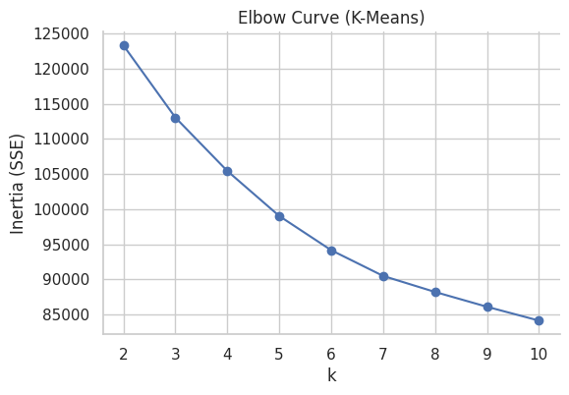
The elbow curve shows inertia (within-cluster sum of squares) decreasing from ~125,000 at k=2 to ~85,000 at k=10. However, the curve shows a gradual decline without a clear "elbow point," suggesting an inconclusive number of clusters in the data.

K-means Clustering and Silhouette Analysis
The analysis further applied K-means clustering method, as shown on the graph, where 5 profiles have started to emerge. To verify with our results, Silhouette Analysis was then used to evaluating cluster quality—measuring how well each observation fits within its assigned cluster compared to others.
Silhouette scores were calculated for k=2 to k=10 Peak silhouette score of 0.116 achieved at k=5, indicating this as the optimal number of clusters. All silhouette scores are relatively low (0.08-0.116), suggesting weak to modest cluster structure in the football match data.
Therefore, k = 5 as the most meaningful structure, even though the silhouette score was moderate, reflecting football’s continuous rather than discrete nature.
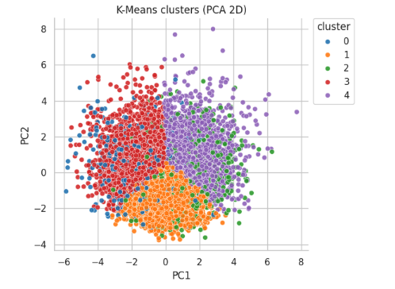 | 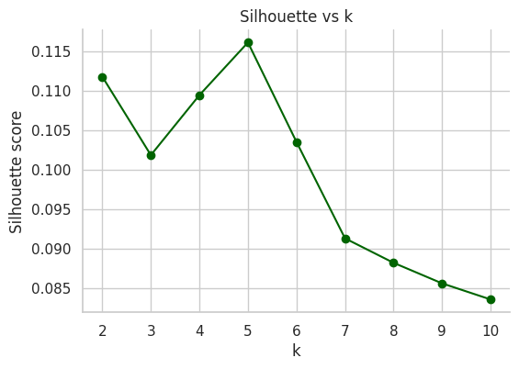
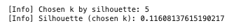

Hierarchical Clustering
To further verify the clustering pattern, Hierarchical Clustering was adopted. The dendrogram has visualized hierarchical relationships among football matches, revealing a clear structure of 5 major clusters with early splits at distances 15–20 indicating fundamental match-type divisions and a final cut at ~25 producing five clusters consistent with K-means results (k=5). This cross-validation strengthens confidence in the chosen solution and provides an interpretable view of how clusters relate hierarchically.

This consistency across methods strengthens confidence in the chosen cluster structure, and the dendrogram provides an interpretable pathway showing how clusters relate hierarchically.
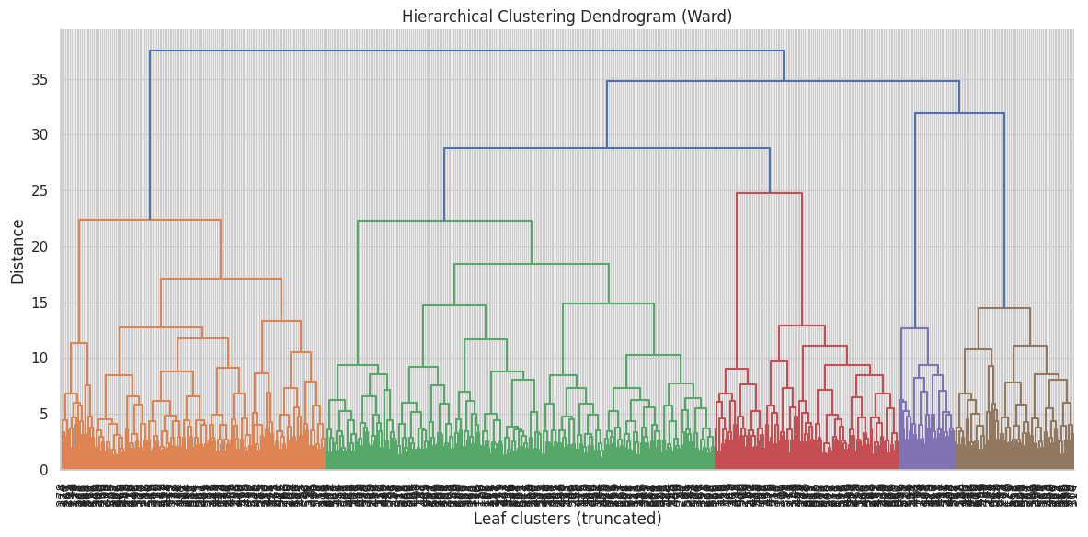
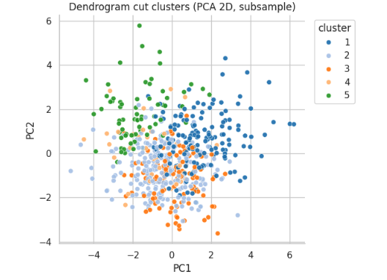 | 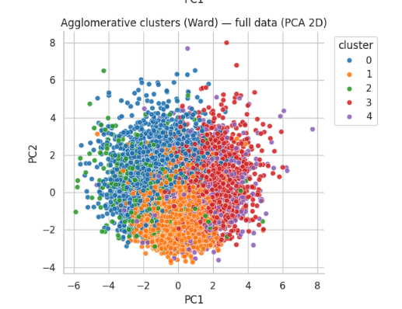
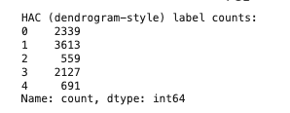

DBSCAN
To validate the clustering robustness, Density-based DBSCAN was used, the analysis revealed that 99.9% of matches were classified as outliers, confirming that football lacks obvious dense groupings and operates on a continuous spectrum rather than discrete categories.
Identified core clusters and outliers Robust to unusual match patterns that don't fit typical cluster shapes Automatically flagged anomalous matches as noise points (-1 label)

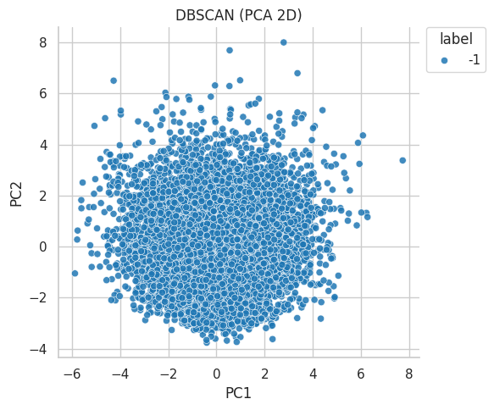

Diving into The Five Football Archetypes
After establishing 5 major groups of football match archetypes, each profiles pattern was explored, each with distinct tactical signatures and predictable outcome probabilities.
By extracting the centroids from the K-Means clustering model and converting back to the original feature scale using inverse transformation scaler, each cluster’s profile is developed. The table and bar chart below shows the differences of values across clusters.

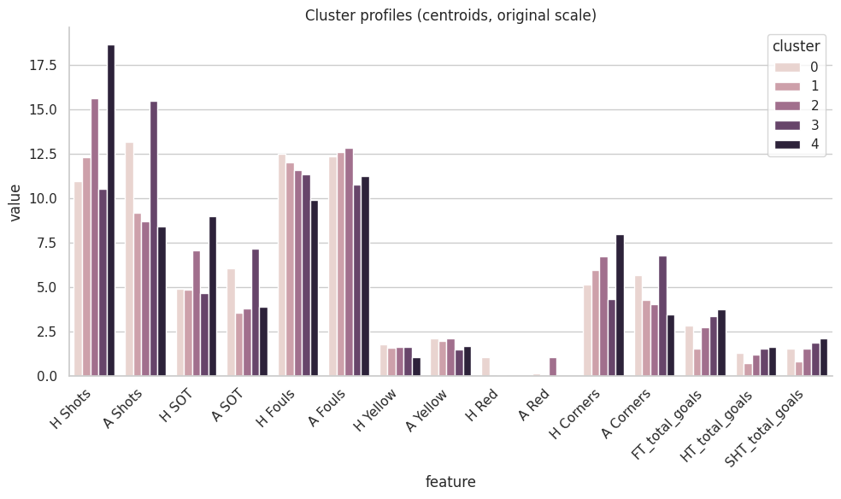
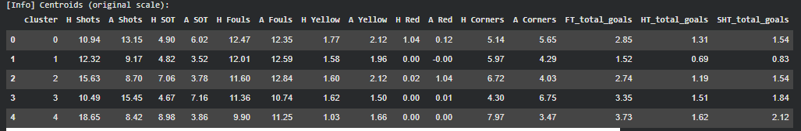
Cluster 1: "Low-Scoring Tactical Battles" (3,613 matches - 38.7%)
The Dominant Pattern
- Statistical DNA: Moderate home shots (12.32), limited away threat (9.17), lowest physicality
- Goals: 1.518 average (defensive specialists)
- Outcome Pattern: Highest draw rate (32.5%), balanced home/away split
- Business Impact: Under 2.5 goals betting, tactical showcase content

Cluster 0: "Away Team Advantage" (2,339 matches - 25.1%)
The Home Advantage Killer
- Statistical DNA: Balanced shots (10.94 H vs 13.15 A), standard physicality
- Goals: 2.846 average
- Outcome Pattern: 50.5% away wins vs 23.4% home wins (rare phenomenon)
- Business Impact: Premium away betting opportunities, challenges conventional wisdom

Cluster 3: "Away Attacking Paradox" (2,127 matches - 22.8%)
The Counter-Intuitive Cluster
- Statistical DNA: Away dominance (15.45 A vs 10.49 H shots), high away corners (6.75)
- Goals: 3.353 average (high entertainment)
- Outcome Pattern: 45.9% away wins despite away attacking dominance
- Business Impact: High-scoring entertainment, destroys defensive away stereotypes

Cluster 4: "Home Spectacles" (691 matches - 7.4%)
The Entertainment Goldmine
- Statistical DNA: Extreme home dominance (18.65 shots), massive corner advantage (7.97 vs 3.47)
- Goals: 3.728 average (highest scoring)
- Outcome Pattern: 66.2% home wins, lowest draw rate (17.3%)
- Business Impact: Premium broadcast content, strongest home betting confidence

Cluster 2: "Physical Battles" (559 matches - 6.0%)
The Rare Encounters
- Statistical DNA: High home shots (15.63), elevated away fouls (12.84), disciplinary issues
- Goals: 2.738 average
- Outcome Pattern: 61.6% home wins, physical intensity favors home crowd
- Business Impact: Niche but reliable home betting value, drama-focused content

Relating Clusters to Match Outcomes

To further relate the practical value of the 5 Football Archetypes, this section explores if clusters have an impact to the home-away advantage and goal outcome. To validate the significance of the five clusters identified to their relationship with match outcomes, this section attempts to explore the relationship of clusters to Full-time results and total goals.

Applying Random Forest Regression to predict match goals

To compare the model performance, the baseline Random Forest model is created with traditional match-level statistics.

- Target variable: total goals scored in match (FT_total_goals)
- Features used:
  - Home/Away Shots
  - Home/Away Shots on Target
  - Home/Away Fouls
  - Home/Away Yellow Cards
  - Home/Away Red Cards
  - Home/Away Corners

By introducing additional features in a supervised learning model we aim to check if it improves predictive accuracy.

The baseline Random Forest Regression model, has achieved an R² score of 0.099, explaining just 9.9% of the variance in total goals scored. In contrast, the model with cluster archetypes as an additional feature has significantly improved performance to an R² of 0.383, explaining 38.3% of the variance.

This shows a 287% increase in predictive accuracy, demonstrating that knowing the match archetype is far more informative than relying solely on raw statistics. A control test with randomly shuffled cluster labels confirmed that this improvement was genuine, as performance dropped back to baseline levels.

These results validated integrating unsupervised clustering insights into supervised models provides a richer understanding of match dynamics and substantially enhances prediction capability.

Key Insights with Impact
After discovering the 5 football archetypes through clustering analysis, this report moves beyond to explore the practical business applications of profiles. This section will examine how the clustered archetypes assist Broadcasters, Betting operators, bettors and team coaches.

Broadcasting Strategy
Aside from football leagues like the EPL, benefitting from the sports and game itself, sports channel broadcasters might find football archetype profile analysis of assistance in predicting the entertainment value and its’ return from viewership.
To relate with our current archetypes, broadcasters are more likely to estimate the viewership by identifying matches likely to deliver high drama, tactical depth, or physical intensity, enabling smarter scheduling and targeted programming.
Beyond scheduling, broadcasters can place smart advertisements on prime matches with high entertainment value, maximizing ad revenue and audience engagement.
As an example, Cluster 4, types of "Home Spectacles" and Entertainment Goldmine (7.4% of matches) might guarantee high entertainment value with an average of 3.7 goals and strong home drama, making it ideal for prime-time slots.
Whereas matches that groups with Clusters 0 and 3 (47.9% combined) are considered as reliable programmes that offer consistent mid-range goal content (2.8–3.4 goals), perfect for regular broadcasts channels. For matches that identifies with Cluster 1 (38.7% of matches) appeals on a tactical niche to purist audiences with draw-heavy, strategy-focused games, while Specialty Content: Cluster 2 (6.0% rare) provides intense physical drama for targeted viewers.

Betting Market Intelligence

Discussed previously from a clustered random forest model, it can enhance the predictability of the goal difference, the model could assist decision-making in a probability-based betting strategy.

Clusters 2 and 4 stand out as strong indicators for Home-Wins, with success rates ranging from 61% to 66%, it is ideal for bettors to seek reliable home-favourite outcomes. On the other hand, Clusters 0 and 3 present lucrative opportunities for away wins, offering 46% to 51% success rates, challenging traditional assumptions about home advantage. For those targeting draw outcomes, Cluster 1 emerges with a 32.5% draw rate compared to 21–26% in other clusters, providing a clear edge in stalemate predictions.

Additionally, goal-based markets can be optimized using cluster-specific threshold matches in Cluster 1 typically average 1.5 goals, while Cluster 4 delivers high-scoring matches with an average of 3.7 goals, enabling bettors to tailor over or under strategies with greater precision.

Team Analytics Enhancement

The integration of clustering archetypes into a Random Forest model offers a different perspective to team analytics. By leveraging cluster analysis, coaches can identify upcoming match archetypes and anticipate opponent tendencies before kick-off. Such prediction could also support team coach’s decision on player’s rotation and select players whose attributes best fit the anticipated archetype demand. For example, prioritizing physical resilience for Cluster 2’s intense battles to creative attackers for Cluster 4’s high-scoring spectacles.

Furthermore, clustering reveals possible non-traditional match dynamics such as Cluster 3’s “away attacking success”, which challenges conventional defensive setups and inspires innovative counterstrategies. When combined with Random Forest’s feature ranking, cluster archetypes could emerge as a dominant predictor of match dynamics, empowering teams to plan strategies proactively with data-driven decision-making.
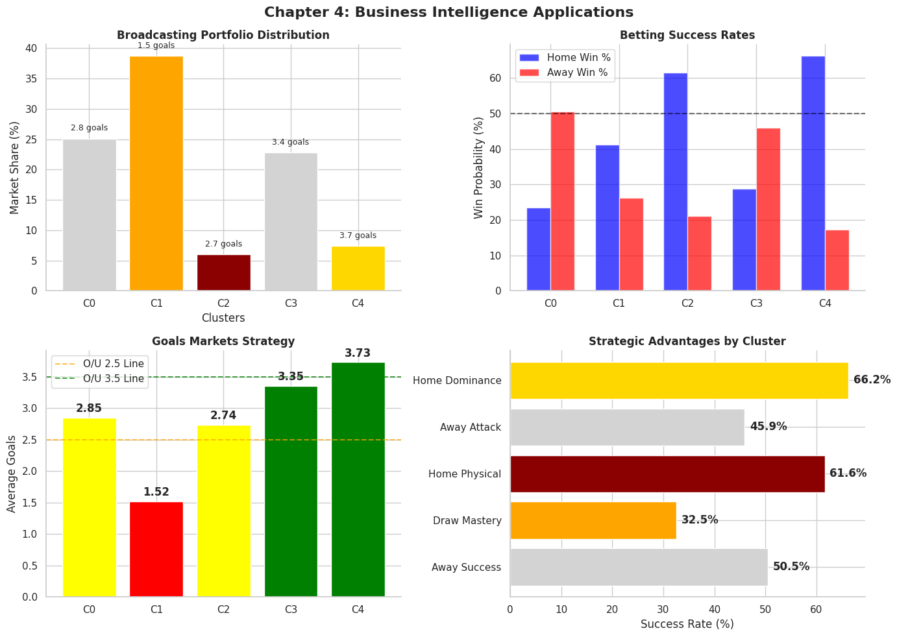 Business Intelligence Dashboard showing cluster applications across broadcasting, betting, and team analytics

Model Limitations

While the Random Forest model with clustering archetype offers significant predictive improvements, there are certain limitations to be taken in consideration. From a statistical point of view, a silhouette score of 0.116 shows a moderate cluster with overlapping boundaries, reducing clusters’ distinctivenes.

Furthermore, a football game’s inherent unpredictable nature could not be fully captured by statistical models. With a 61.7% of variance in match outcomes remains unexplained and findings from The DBSCAN analysis showing that matches exist on a continuous spectrum rather than discrete categories, it highlights the fluid nature of football dynamics.

Stakeholders who wish to adopt a cluster-backed probabilities should proceed with caution and position the approach as guidance rather than guarantees. Such approach should serve as a complementary analysis, among other factors such as team form, player availability, and tactical analysis. Ultimately, while clustering enhances predictive power of winning teams, it does not eliminate uncertainty that keeps football exciting and unpredictable.

Recommendations, Next Steps, and Conclusion
Referring to our analysis above, users may notice that the five-cluster archetypes are more than just academic curiosities – they are business intelligence findings that can be applicable to real-life situations – whether that is for betting markets, for broadcasters & media, or for team coaches and strategists. We urge the stakeholders to move from generic match-level analysis to this cluster-based approach as their analytical baseline. Our recommendations, future work, and conclusions are shown below.

Recommendations
For football bettors, our findings mean that a betting framework based on cluster-based odds models is superior to the current, widely-used match-level statistics models, as our findings indicate home advantage is absent in “Cluster 0” but apparent in “Cluster 4”. Based on this, we believe predictive models that stem from and are weighted on cluster outcomes would offer an edge that other current models are unable to match, as the latter are still based on match-level statistics. For example, bettors may find that matches under “Cluster 1” (Low-Scoring Tactical Battles) normally have a goal score around 1.5, while “Cluster 4” (Home Spectacles) matches have a goal score of 3.5 or higher. Referring to the validation result, we believe betting models will gain a more accurate statistical baseline by incorporating the give-cluster archetype as a feature. This, leading to an improved predictive performance.
For broadcasters and media stakeholders, we recommend an archetype-based TV programming schedule. This approach allows them to maximize streaming revenue, for example, by selling subscriptions on a stand-alone basis for the most attractive and exciting series based on the cluster's recommendation. In addition, a good user experience is highly related to a sustaining revenue stream. Broadcasters can maximize audience engagement by promoting the watching experience rather than just the teams. For example, "Cluster 4" and "Cluster 3" matches should be promoted as premium "must-watch" series. "Cluster 2" could be sold as intense "Rivalry" series for die-hard fans, while "Cluster 1" could be packaged as tactical, focused matches for football fans who appreciate strategies. This "slice and dice" strategy could potentially improve the broadcaster's revenue and increase customer stickiness.
Lastly, for coaches and team strategists, our findings on the cluster-based model offer advantages in two ways. First, the cluster-based model enables coaches to better understand the dynamics of matches throughout the game season, allowing them to better scout suitable players and prepare them with more targeted training regimens. For example, in leagues with more “Cluster 2” matches, a manager should prioritize set-piece drills focused on improving physical strength. Second, based on the Archetypes, coaches and team strategists are equipped with information prior to game play, enabling them to select the “starting eleven” that best fits the anticipated cluster. For example, if a “Cluster 2” game is anticipated, a manager should prioritize physically robust players. This approach differs from the game-level decisions they are used to, allowing them to think at a cluster level, which may provide different insights and new strategic angles.

Next Steps
While our analysis has unearthed a new perspective on the game, it’s undeniable that its true business value lies in superior prediction. Therefore, we propose the following future research directions, stemming from our current work:
Although our project has rigorously implemented logistic regression and made relevant predictions, it still leaves room for more advanced models, such as a neural network. This study sees the potential for a neural network to further improve predictive performance by capturing the complex, non-linear relationships in the dataset-such as player matchups, weather, and complex team dynamics-which a linear model like logistic regression is unable to do. While time-consuming and complex, we recognize the potential of neural networks and identify this as a logical "low-hanging fruit" that the next research direction could achieve with reasonable effort.
Another area that is worthwhile to explore is data enrichment. Admittedly, our dataset, while comprehensive, does not encompass all the data that could reasonably be deemed useful. For example, matches are highly affected by both player-specific data (e.g., distances covered, individual player ratings, or a player's mental strength) and external data (e.g., weather conditions or the percentage of home vs. opposing supporters). Given our regression model still leaves 61.7% of goal variance unexplained, there is ample room for improvement by simply enriching the data via new and advanced data sources. We believe this effort, coupled with the implementation of neural networks, could further enhance our predictive performance. This, in turn, would lead to even superior business applications and create a virtuous cycle for our clustering model.

Conclusion
To summarize, this project successfully navigated football's “random walk” to find patterns within 9,000 matches, transforming chaotic data into clear, actionable business insights. Our study proves that Premier League matches are not random events; they follow clear, distinct archetypes that function as the game’s underlying DNA-in our case, five predictable types.
From a technical perspective, we performed rigorous validation via Hierarchical Clustering and confirmed the predictive performance using Logistic Regression. As shown above, incorporating our five archetypes as an underlying feature improved predictive accuracy by 287% ($R^2$ from 0.099 to 0.383), making it a more powerful predictor than any single, stand-alone traditional feature.
Most importantly, this study has not just found patterns; it has unearthed a new, proven statistical baseline for identifying and classifying team playing styles and match dynamics. This provides a ready-to-use, data-driven framework for revolutionizing business applications in betting, broadcasting, and coaching. To finish, this project proves that machine learning, when done right, can decode the beautiful yet uncertain game, transforming the “random walk of football” into a predictive and measurable strategic advantage.

